Dear Parents,

Hello, my name is Alun Hixson and I will be working with this class of Year 1s for the next two weeks as part of my pre-service teaching practice to develop my teaching skills to become a more effective teacher. I feel very privileged and excited to have this opportunity to have my pre-service teaching practice at this school and to work with these students. I am training at Murdoch university to be a primary education teacher and a specialist in physical education from years 1-10.

My personal interest revolves around teaching and developing ways in which I can enhance my understanding of how students evolve and learn so that I can further develop student learning. I hope to connect with and get to know all the students. My other passions/interests involve sport and I believe that is where my talent lies. I enjoy playing sport but most of all I enjoy teaching and helping students develop their sporting skills. I believe it is important to develop an interest in sport and exercise because this fosters a healthy lifestyle, social skills and overall wellbeing.

I want to teach physical education because it is fun and enjoyable for both the teacher and the student. I have completed two community coaching certificates throughout my studies at the university, and I am a qualified lifeguard and trained in first aid. I believe I can teach all types of sports effectively, because I believe that technique is key, and if children are taught skills correctly at a young age they will be more effective in sport as they grow and develop.

As an educator in my second placement and through the use of co-teaching, I will be teaching a combination of English literature, the arts and drama, and also my speciality of physical education. All together I will teach as many as 18 lessons. I will have to plan lessons ahead of time and also get to know all of my students in this experience so that I can implement effective lessons which flow, so all students can be involved. I will ensure my classroom is inclusive and is a safe learning environment for all the students in the classroom. I will create an effective learning environment where all students can thrive through their education and understanding of topics being taught. I would like to thank everyone who is involved for this opportunity.

Sincerely,
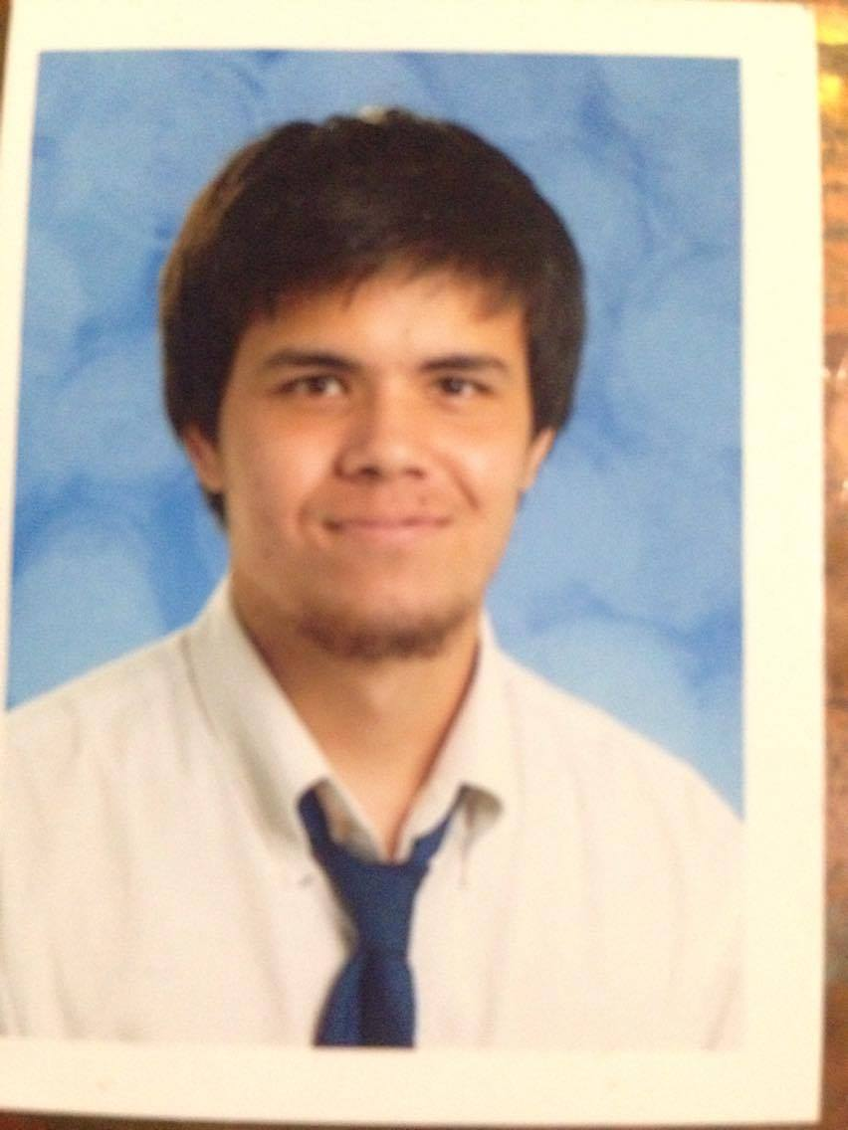
Alun Hixson

