EDN2104 Assignment 1 topic 4
This week explores your resilience and reflective practice; two essential skills for future teachers. First, complete the BRITE Module B - Building Resilience Module B. Use your knowledge of the General Capabilities and the AITSL Teacher Toolkit. Second, upload this onto your already established eportfolio established.
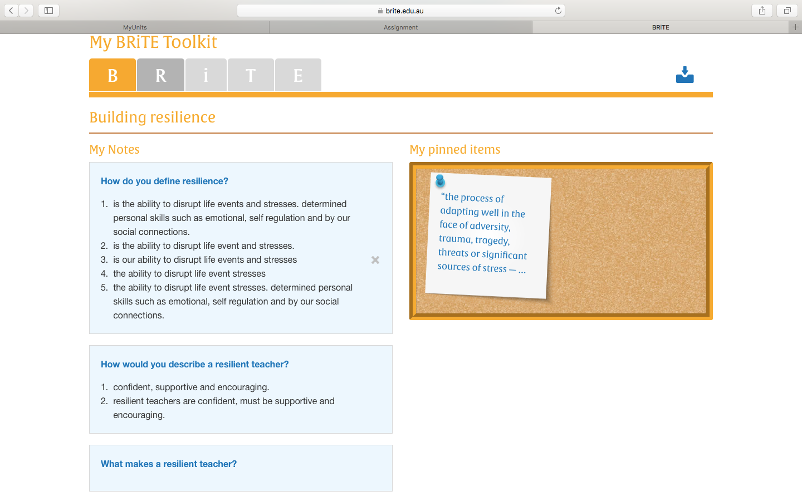
BRITE Screen shot

