Topic 3 Choose a platform to develop your own Professional Learning Portfolio framework (if you haven't already done so). Use the AITSL professional standards and sub-standards as headings, upload all of the english websites introduced in EDN235 (formerly EDN282) to the appropriate standard for your future reference whilst on placement. Upload (Submit your url and a snapshot of the front page to LMS - Topic 3)

website URL: http://alunsweb.weebly.com
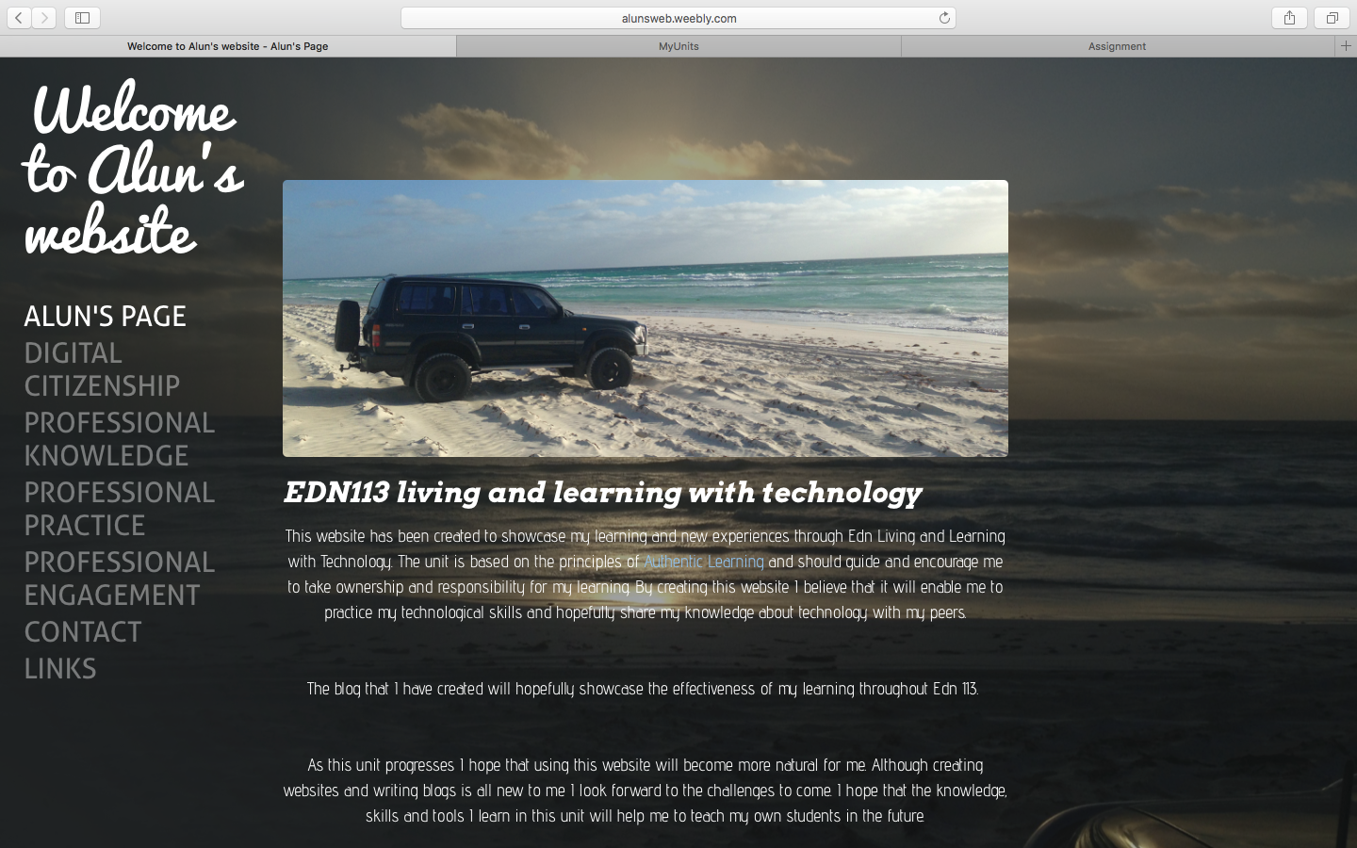
website snapshot

